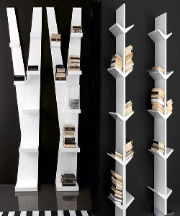

Durian IKEA Lack Wall bookcase

$163.39

Availability: In stock

**Description:**

Shallow shelves help you to use small wall spaces effectively by accommodating small items in a minimum of space. Choose whether you want to place it against the wall or hang it horizontally or vertically. Good to know This furniture must be fixed to the wall with the enclosed wall fastener. Different wall materials require different types of fixing devices. Use fixing devices suitable for the walls in your home, sold separately. Load/shelf is valid only when the wall shelf is mounted vertically. care instructions. Wipe clean with a cloth dampened in a mild cleaner. Wipe dry with a clean cloth.